**Questions for Investigation**

As a general note, be sure to keep a record of any resources that you use or refer to in the creation of your project. You will need to report your sources as part of the project submission.

1. What is our independent variable? What is our dependent variable?

**Answer:** The independent variable here is the COLOR of the ink, in which the words are displayed. The dependent variable is the TIME it takes to name the ink colours.

2. What is an appropriate set of hypotheses for this task? What kind of statistical test do you expect to perform? Justify your choices.

**Answer:** The hypothesis for this task is as follows:

**Null hypothesis** – There is no significant time difference between reading the congruent and incongruent word list. We denote this by µC = µI (mu C = mu I)

**Alternative hypothesis –** There is a significant time difference between reading the congruent and incongruent word list. We denote this by µC ≠ µI (mu C ≠ mu I)

We will perform a **dependent t-test for paired samples**, since the same participants take both the congruent and incongruent condition tests (same subject is subjected to **two different conditions**).

Now it’s your chance to try out the Stroop task for yourself. Go to [this link](https://www.google.com/url?q=https://faculty.washington.edu/chudler/java/ready.html&sa=D&ust=1517037820133000&usg=AFQjCNELARvEKYdtuRkJqvOrzb8051cg_A), which has a Java-based applet for performing the Stroop task. Record the times that you received on the task (you do not need to submit your times to the site.) Now, download [this dataset](https://www.google.com/url?q=https://drive.google.com/file/d/0B9Yf01UaIbUgQXpYb2NhZ29yX1U/view?usp%3Dsharing&sa=D&ust=1517037820133000&usg=AFQjCNGXcXrWL-sv3h__uYQfkbekk5N-5Q) , which contains results from a number of participants in the task. Each row of the dataset contains the performance for one participant; with the first number their results on the congruent task and the second number their performance on the incongruent task.

3. Report some descriptive statistics regarding this dataset. Include at least one measure of central tendency and at least one measure of variability.

**Answer:**

Congruent list: Mean=14.0511, Standard deviation = 3.5593

Incongruent list: Mean=22.0159, Standard deviation = 4.7970

Standard deviation of the differences between Incongruent list and congruent list values (Incongruent list – Congruent list) = 4.8648

4. Provide one or two visualizations that show the distribution of the sample data. Write one or two sentences noting what you observe about the plot or plots.

**Answer:**

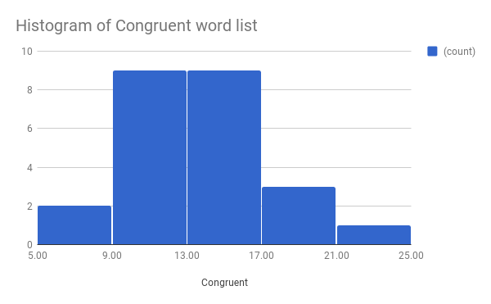

In the histogram of congruent word list, bin size is 4. The values between (9,17) have a maximum frequency of over 8.

5. Now, perform the statistical test and report your results. What is your confidence level and your critical statistic value? Do you reject the null hypothesis or fail to reject it? Come to a conclusion in terms of the experiment task. Did the results match up with your expectations?

**Answer:**

The mean values for the congruent and incongruent samples serve as point estimates for the populations from which they have been sampled.

Hence, when calculating the t-statistic, the sample means can be used in the numerator.

**t-statistic** = (22.0159 - 14.0511)/SEM

**SEM** = SD of the differences /sqrt (n) = 4.8648/sqrt (24) = 4.8648/4.8989 = 0.9930

**t-statistic** = (22.0159 - 14.0511)/0.9930 = 8.0209

For a 95% CI and an alpha-level of 0.05, degrees of freedom = 23, the t-critical = 2.069.

Since our t-statistic is past our t-critical value, **\*\*we reject the null hypothesis**.**

We conclude that there is a \*\***significant time difference\*\*** between reading the congruent list and the incongruent list.

6. Optional: What do you think is responsible for the effects observed? Can you think of an alternative or similar task that would result in a similar effect? Some research about the problem will be helpful for thinking about these two questions!